0-3 Fractions Worksheet
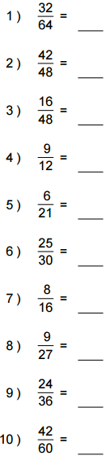

Converting Improper Fractions to Mixed Numbers
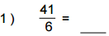
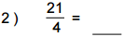
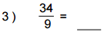
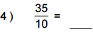
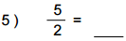
Converting Mixed Numbers to Improper Fractions
